Copyright for test papers and marking guides remains with West Australian Test Papers.
Test papers may only be reproduced within the purchasing school according to the advertised Conditions of Sale.
Test papers should be withdrawn after use and stored securely in the school until Wednesday 10th October 2018.


MATHEMATICS
METHODS
UNITS 3 & 4

Semester Two

2018

SOLUTIONS

Calculator−free Solutions

1. (a) 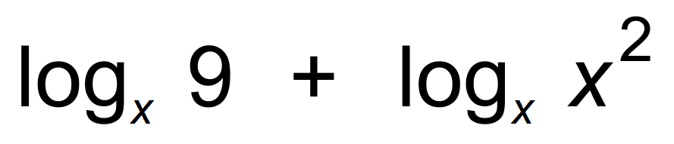
= 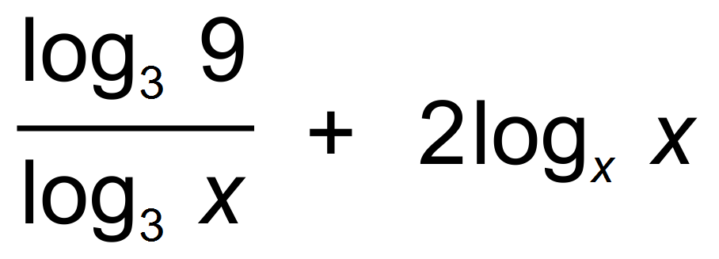
= 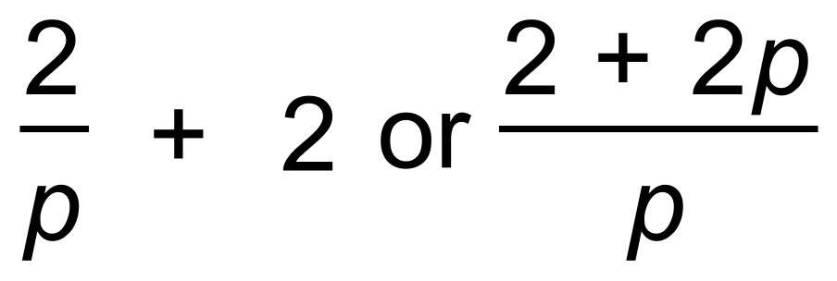
(b) 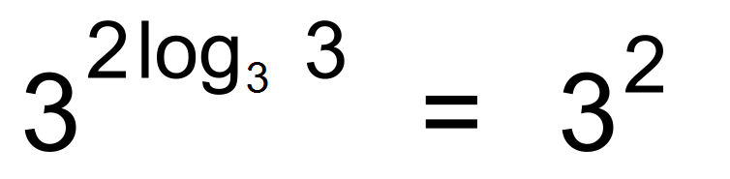
= 9
(c) 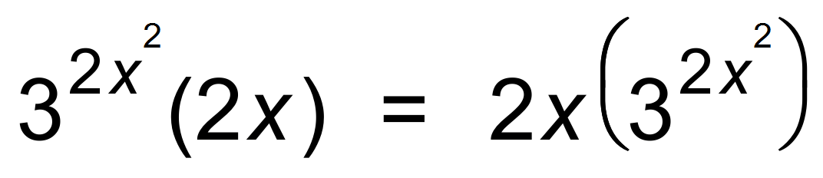 [7]

2. (a) 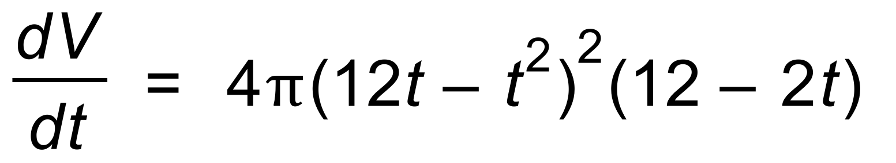
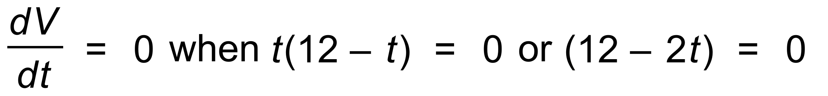
∴ 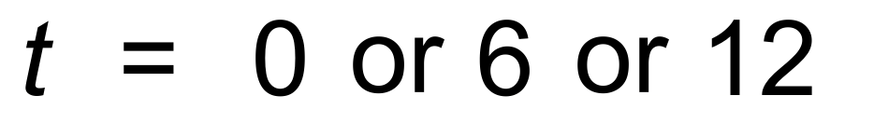
Using the sign table yields Maximum occurs at t = 6
(b) (i) 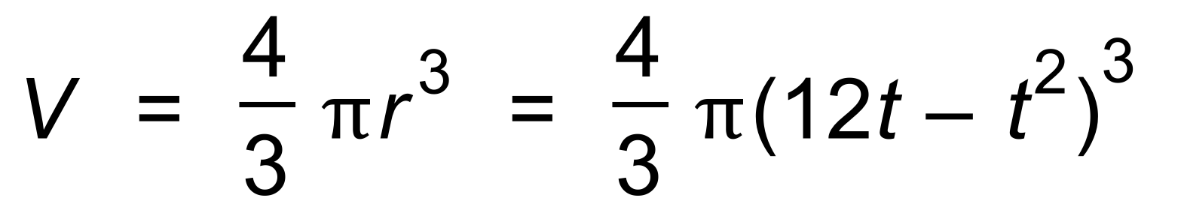
∴ 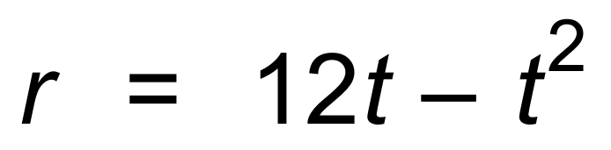
(ii) When 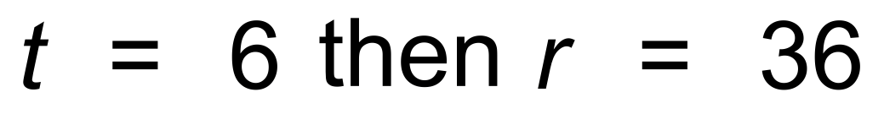
r =36 is the maximum value of r, so max Volume. [8]

3. (a)
= 2.35
= 3.25
(b) 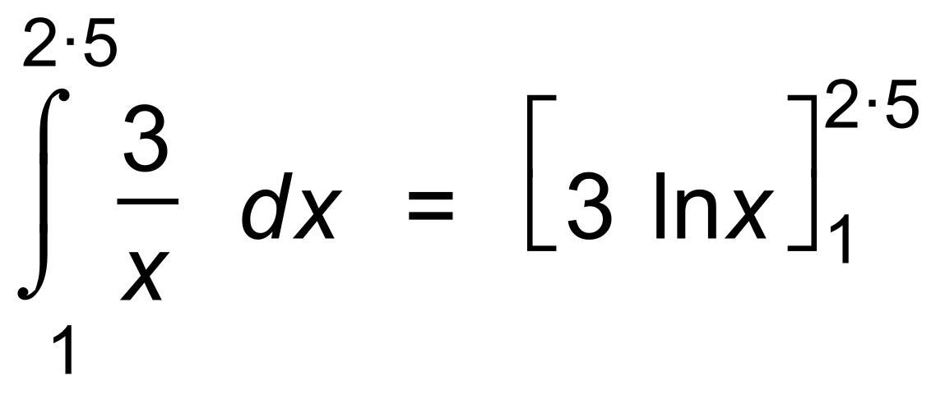
= [6]

4. (a) 0.07
(b) 0.25
(c) P(1) = (0.1)² = 0.01
P(2) = (0.15)² = 0.0225
∴ P(1) + P(2) = 0.0325
(d) Unbiased would be uniform [5]

5. (a) 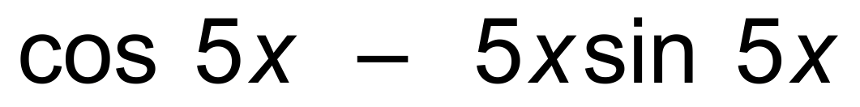
(b) 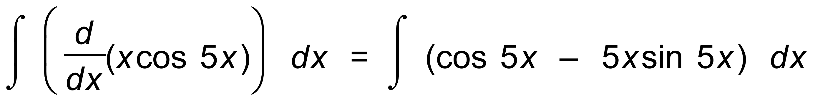
∴ 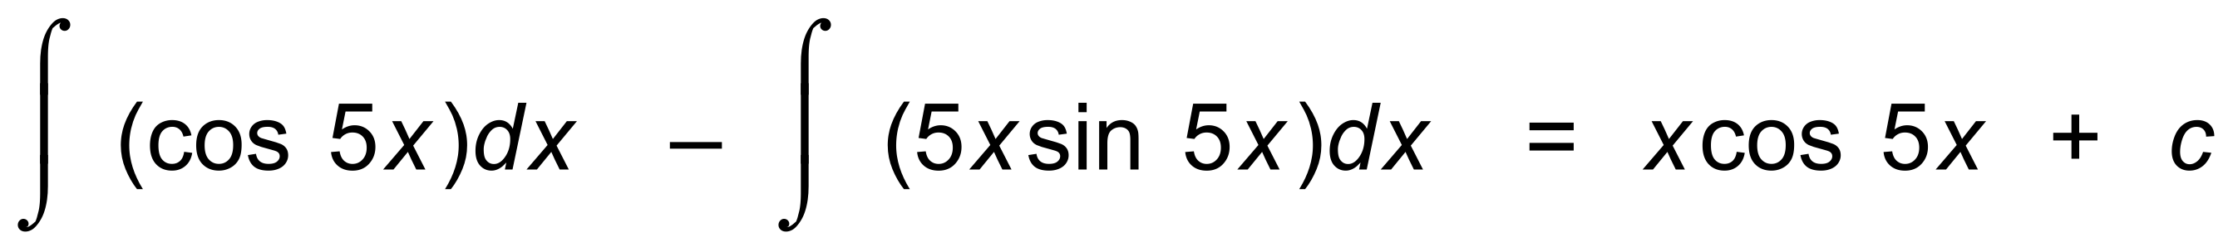
∴ 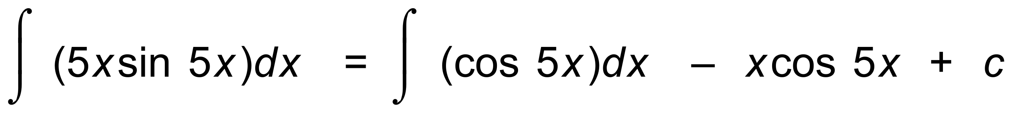
∴ 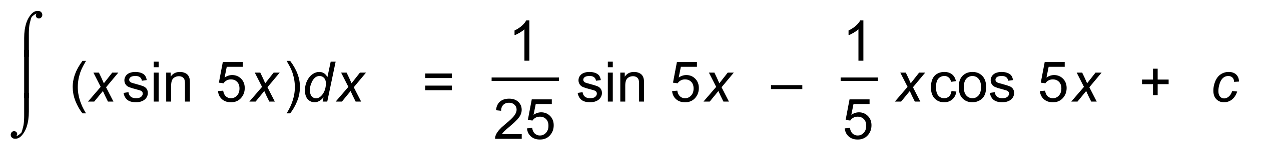 [6]

6. 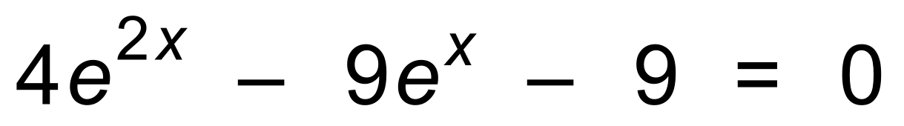
Let 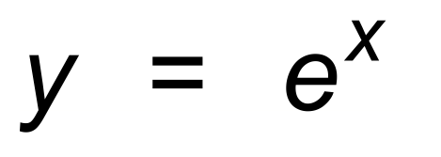
∴ 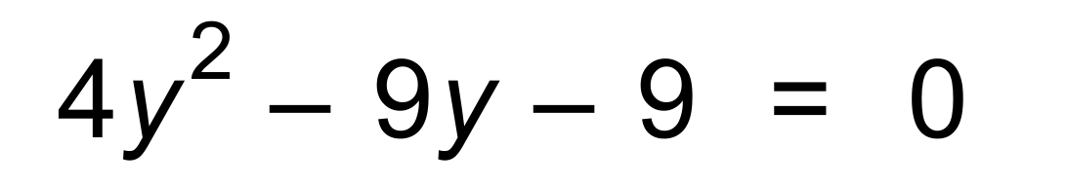
∴ 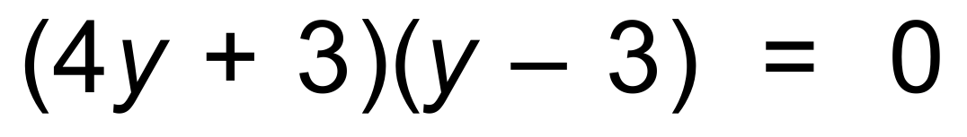
∴ 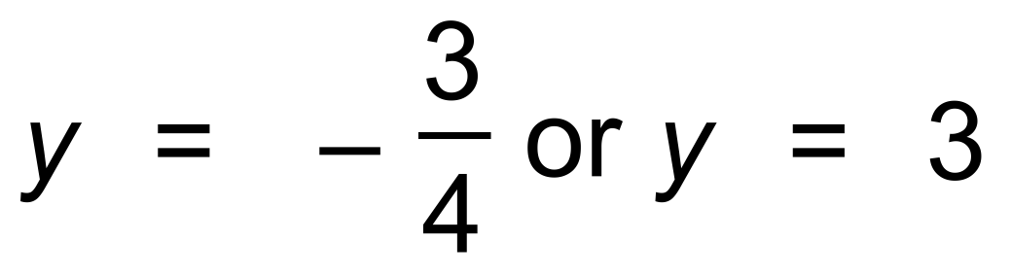
∴ 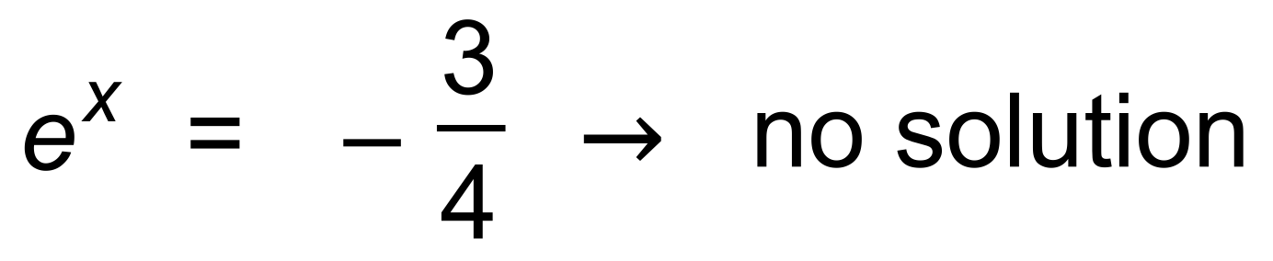
and 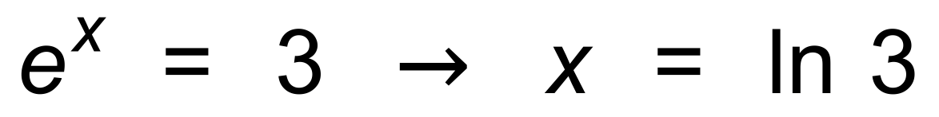 [5]

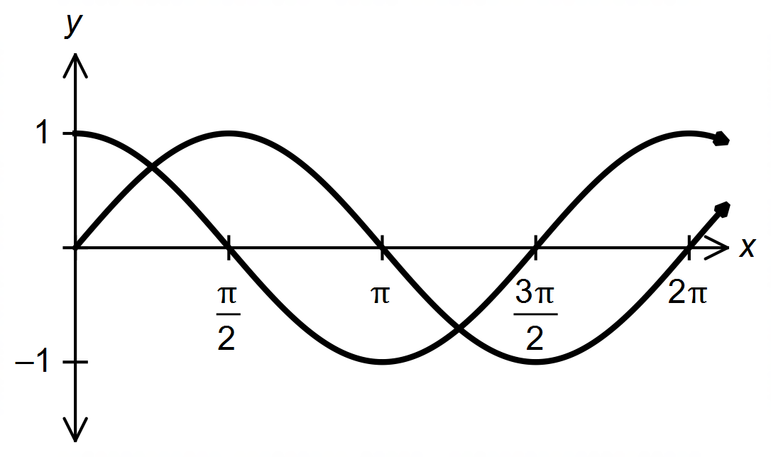7. (a)

(b) 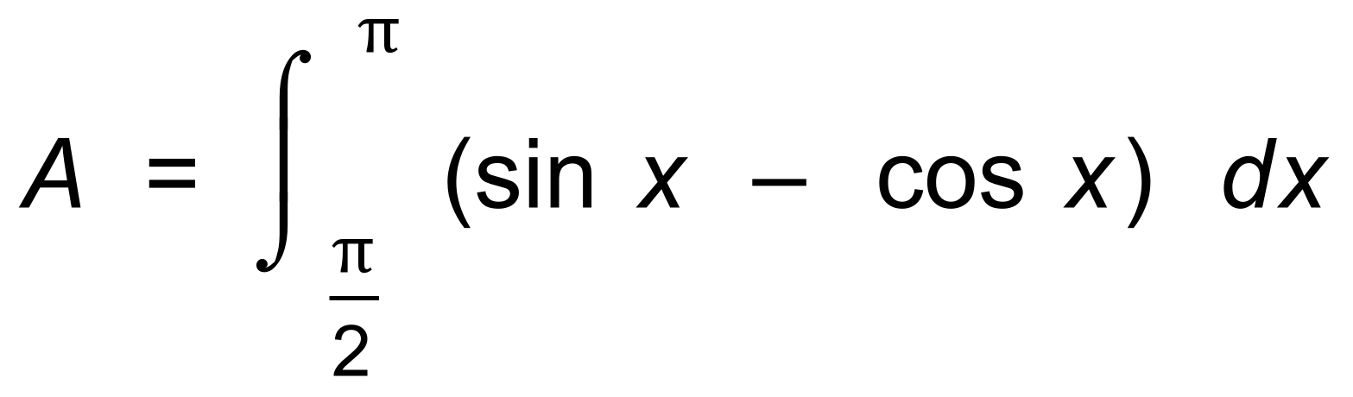
= 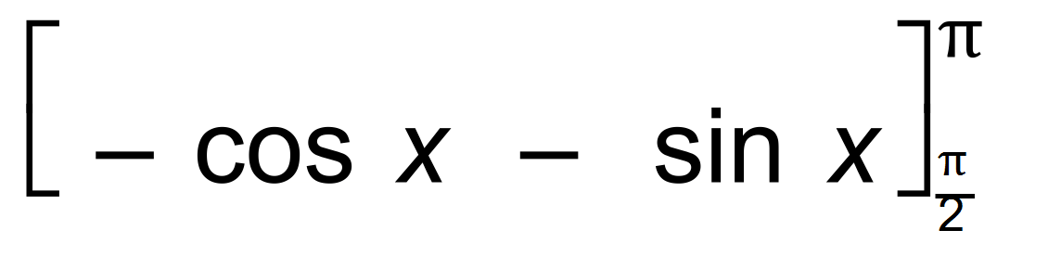
= (0 + 1) −(−1 − 0) = 2 [5]

8. 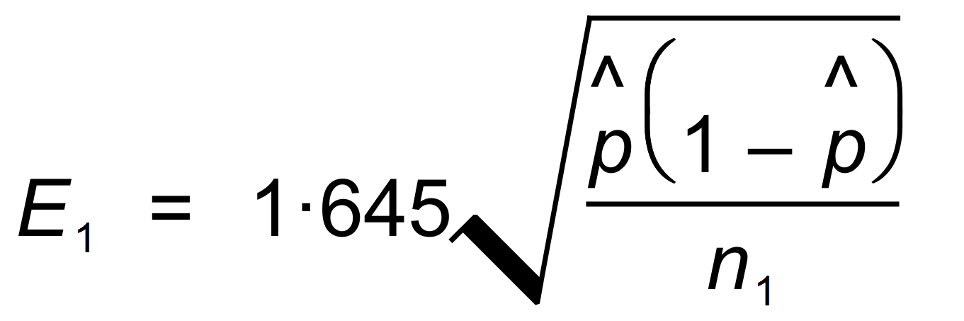
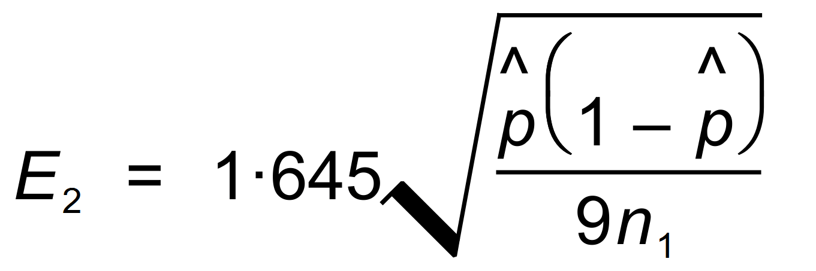
∴ 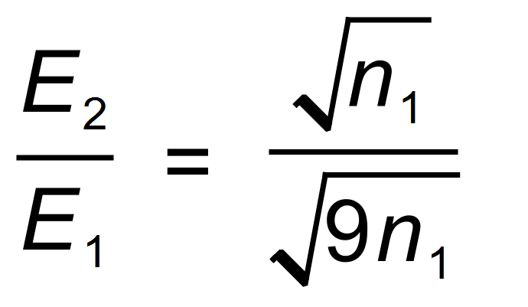
= 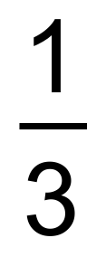 [3]

9. (a) ln |sin x| + c
(b) 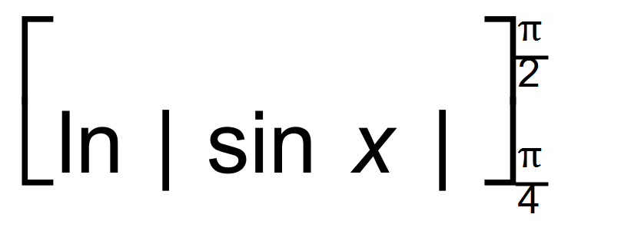
= 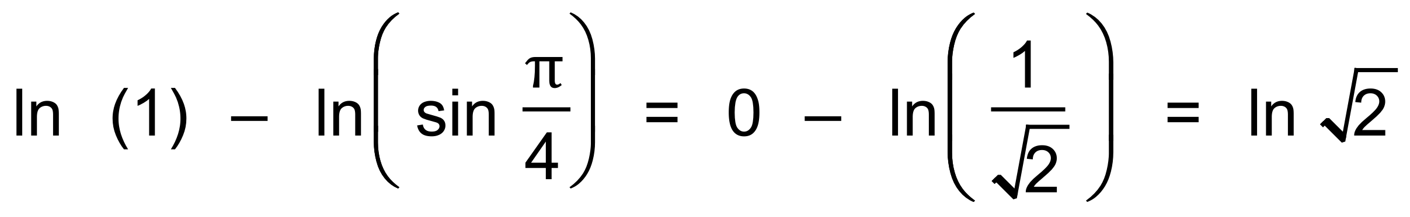
= 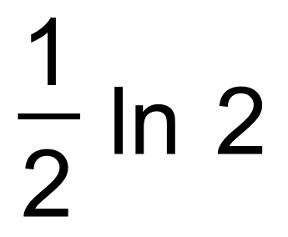 [5]

Calculator−assumed Solutions

10. (a) 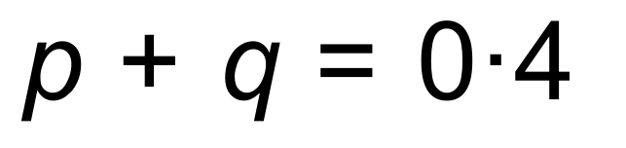
∴ From CAS p = 0.3 and q = 0.1
(b) E(X) = 0.2 + 0.6 + 0.9 + 0.4 + 0.5 = 2.6
(c) E(Y) = 1 − 5.2 = −4.2 [5]

11. (a) 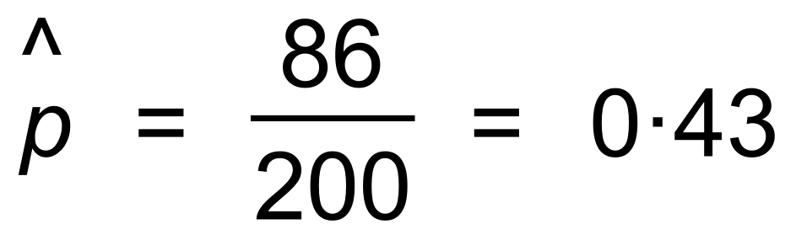
(b) 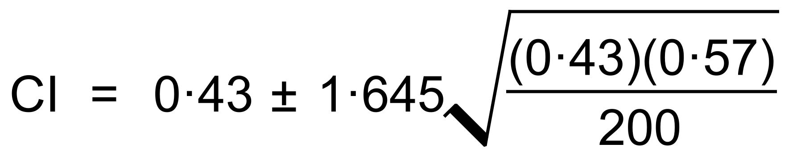
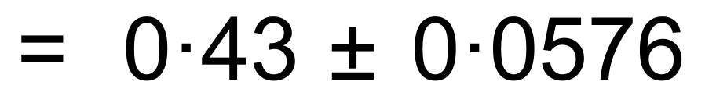
∴ 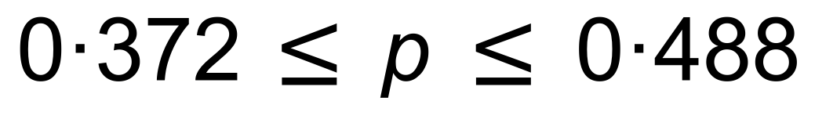
(c) The mean suggested by the CI is 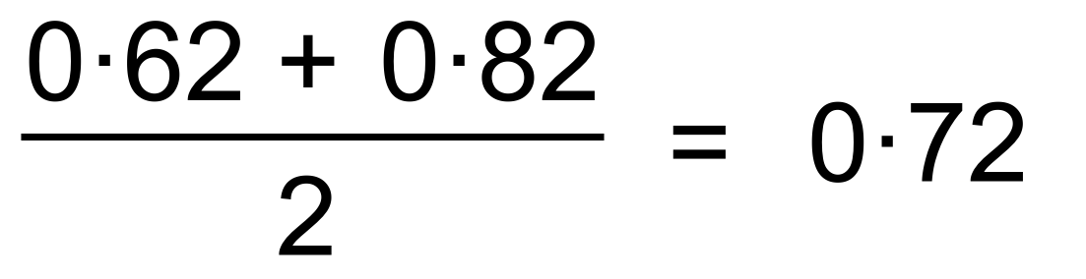
This does not lie within the 90% CI as calculated in (b)
∴ Evidence doesn’t support the claim.
(d) (i) Binomial requires independent events and a constant
probability of success. Neither criteria apply here.
(ii) 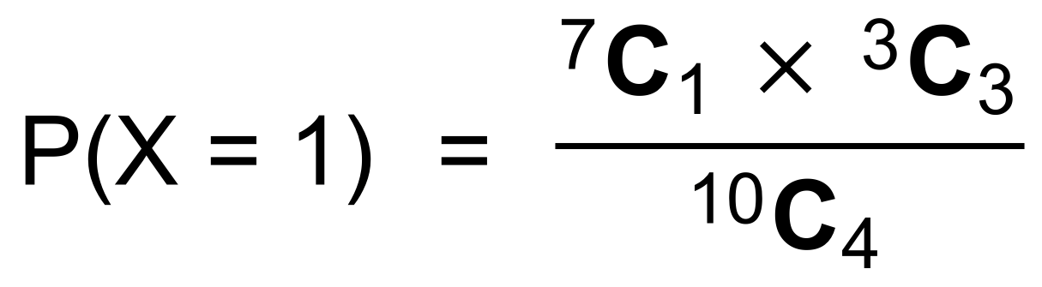
= 0.1 [12]

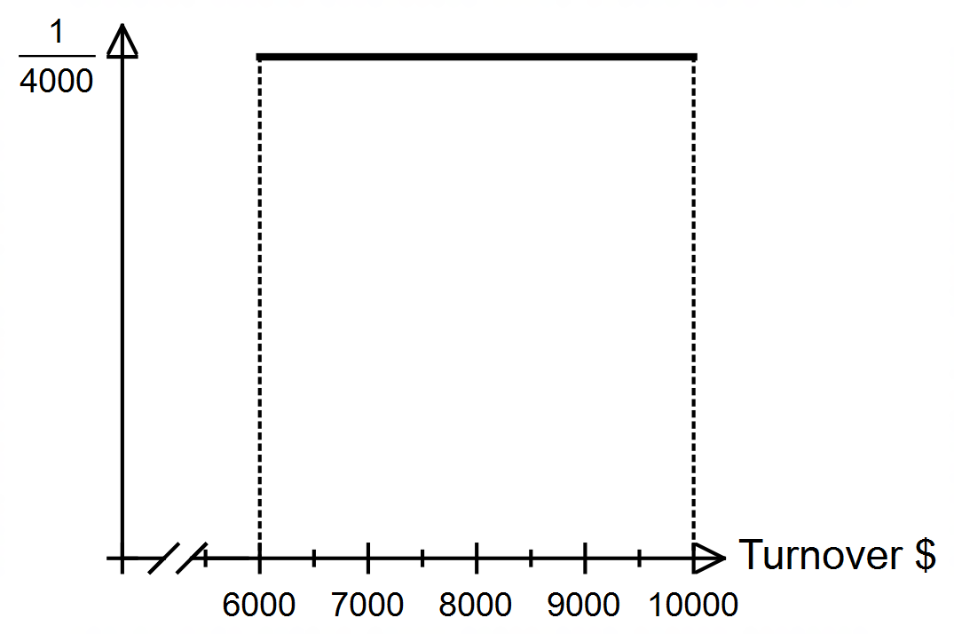12. (a)

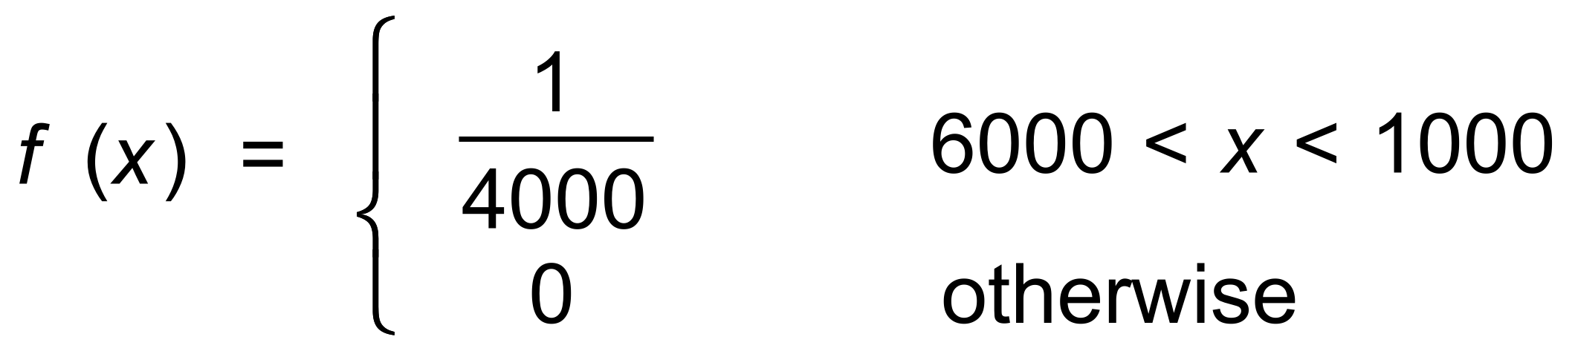

(b) (i)
(ii) 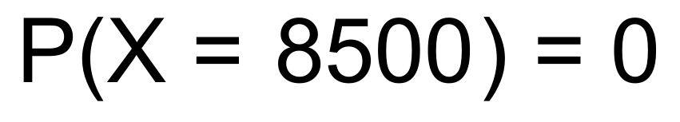
(c) 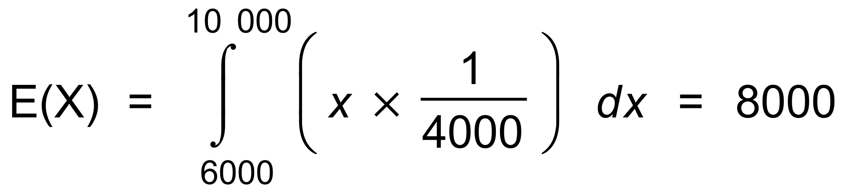
(d) (i) 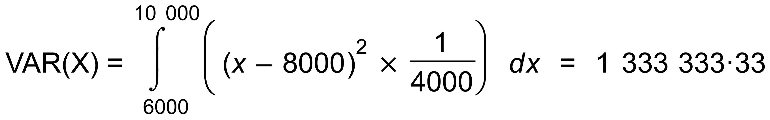
∴ 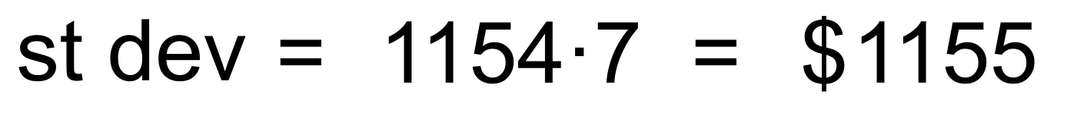
(ii) Standard deviation = $1155
Not affected by change of origin [10]

13. (a) (i) 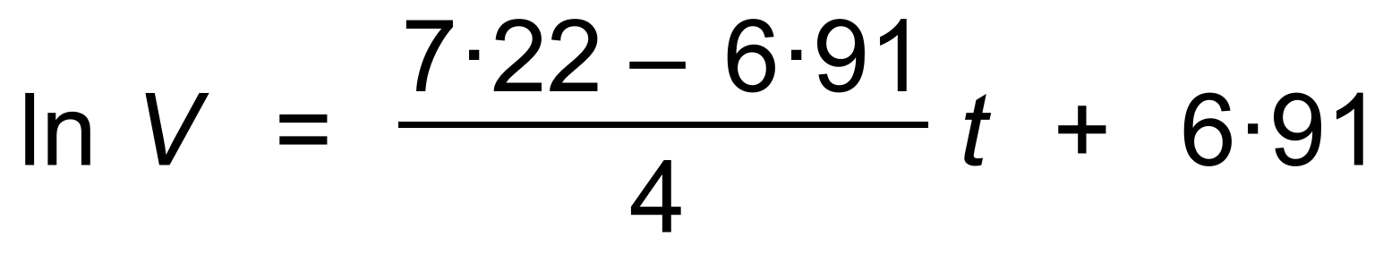
∴ 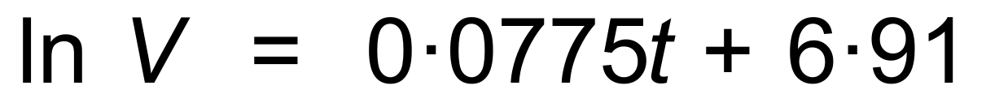
(ii) 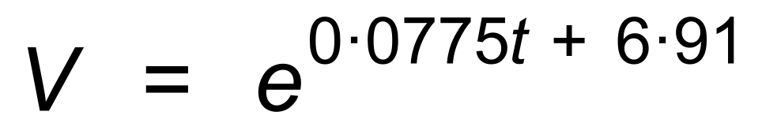
∴ 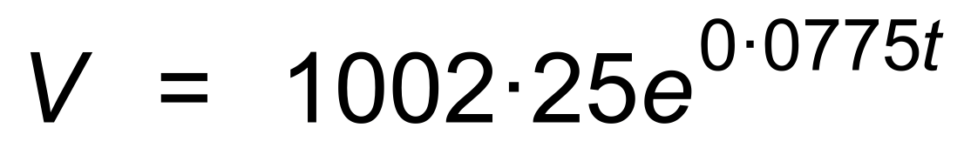
(b) 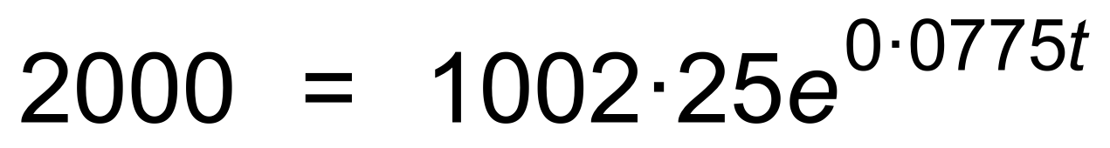
∴ 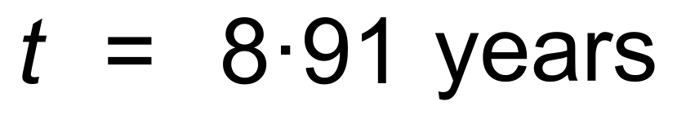
(c) 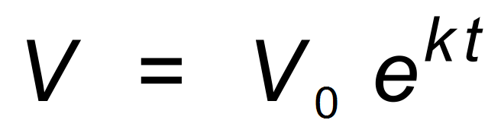
∴ 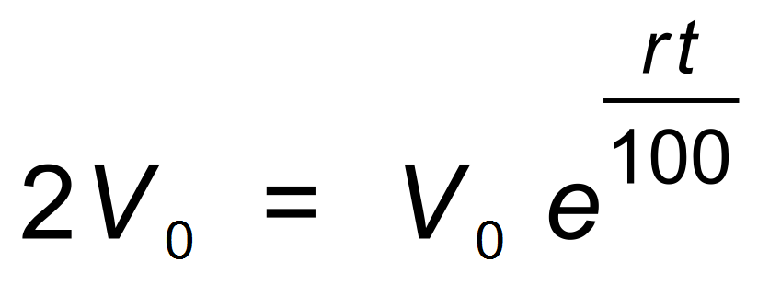
∴ 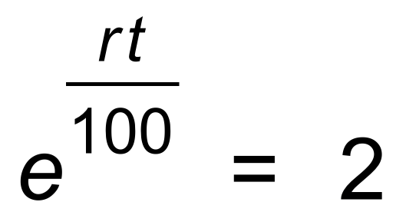
∴ 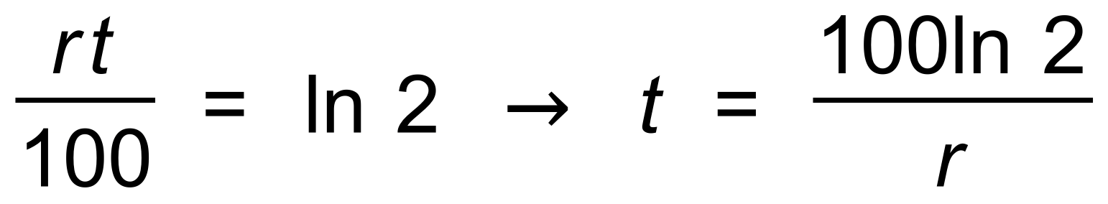
∴ 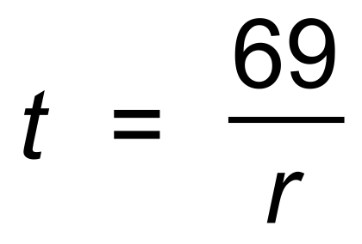 [9]

14. (a) 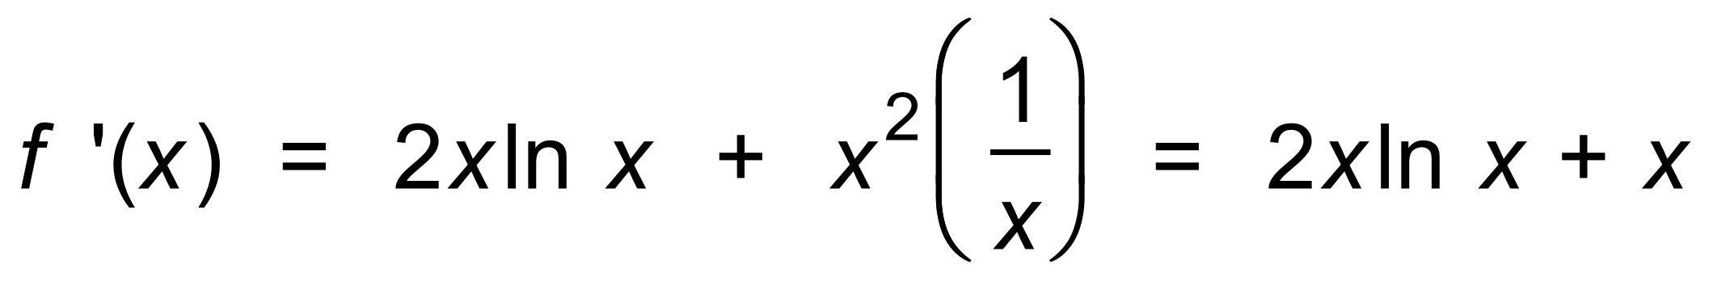
∴
∴ 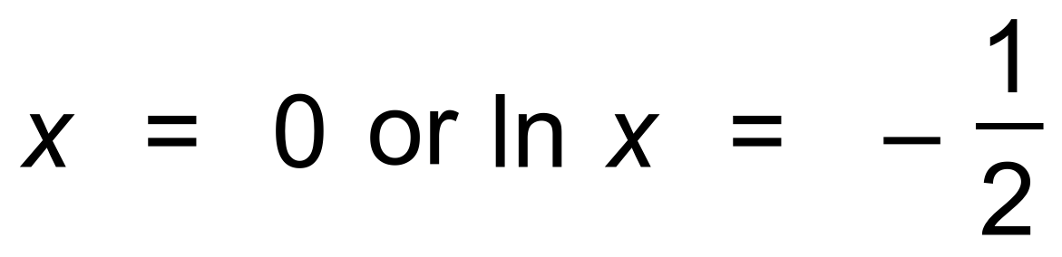
ie 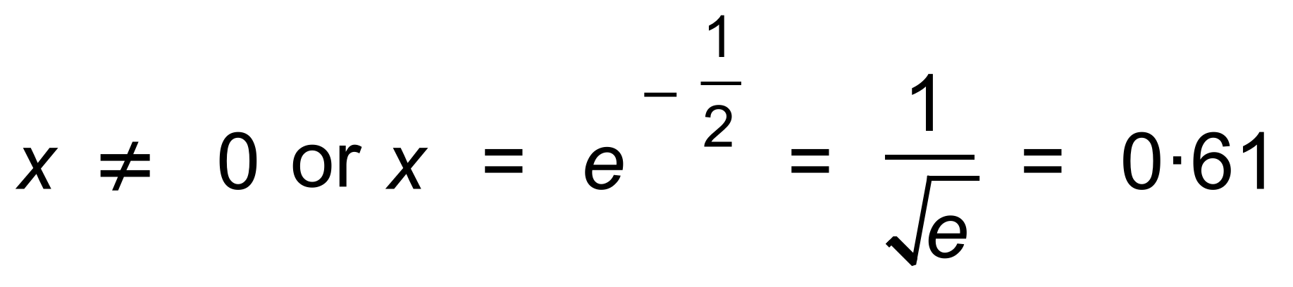
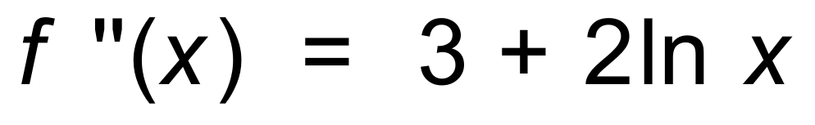
∴
(b) 
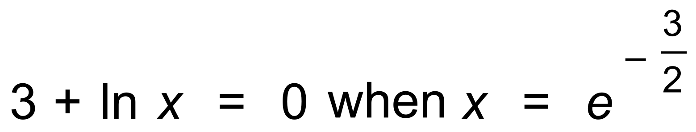
∴ Oblique POI at 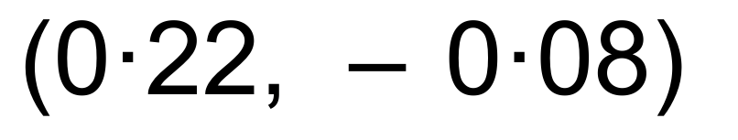
(c)
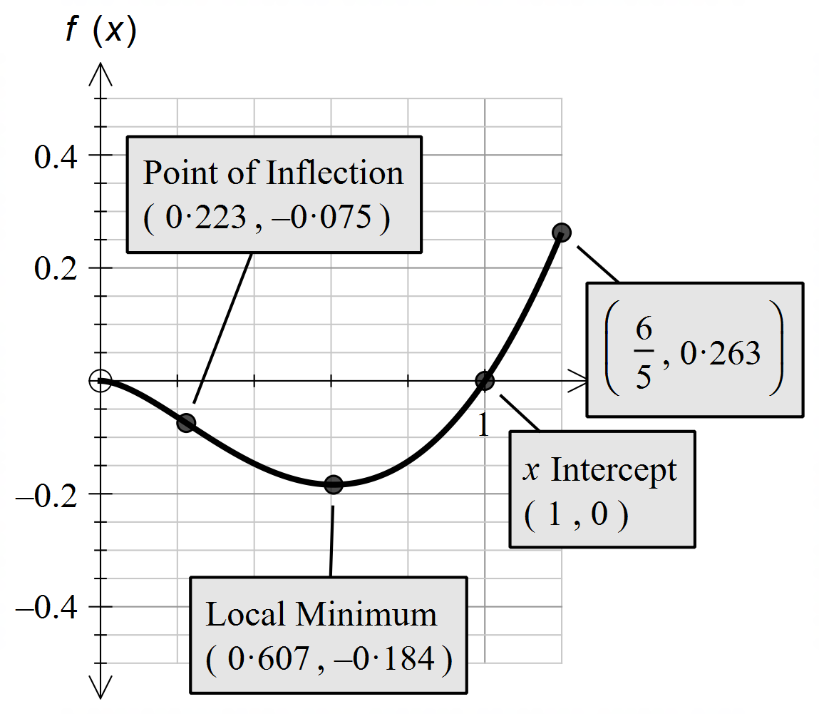

[12]

15. (a) (i) 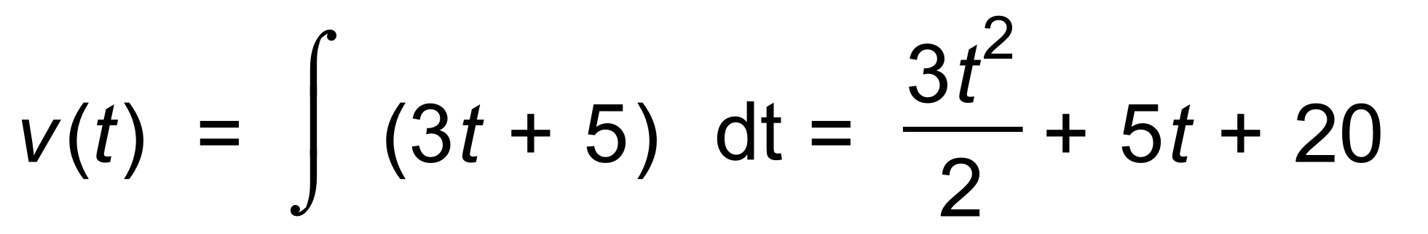
∴ 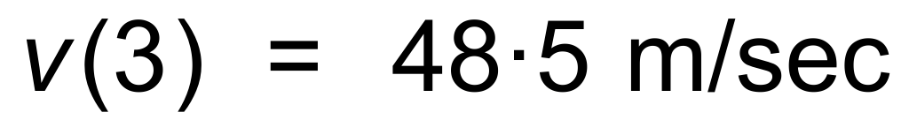
(ii) 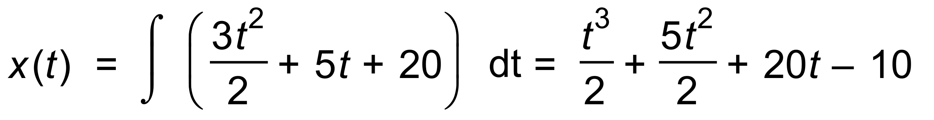
∴ 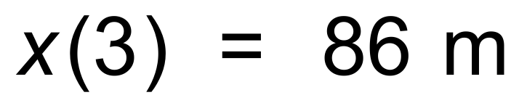
(b) 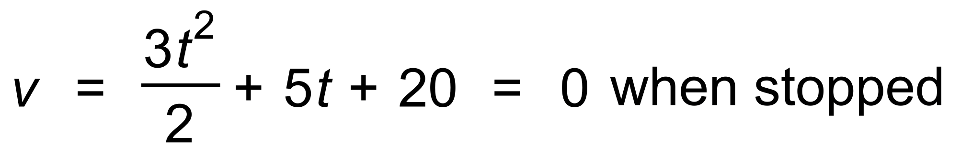
However 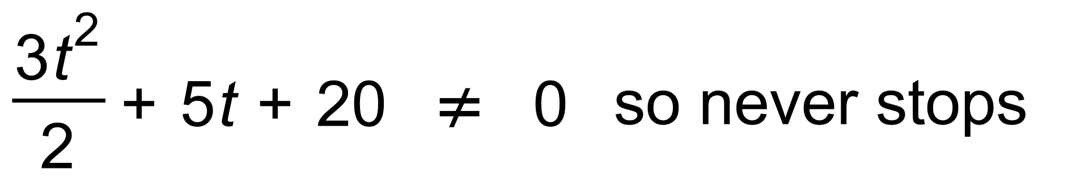
(c) Distance travelled = 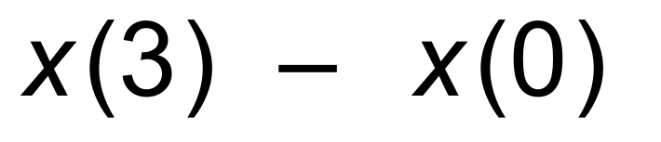
∴ 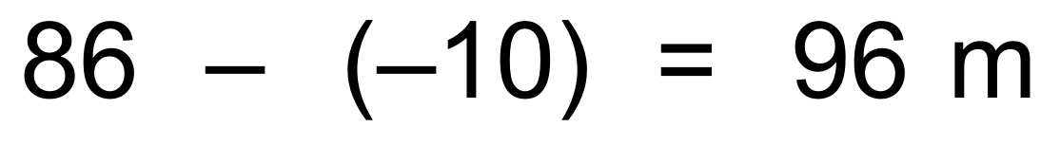 [10]

16. 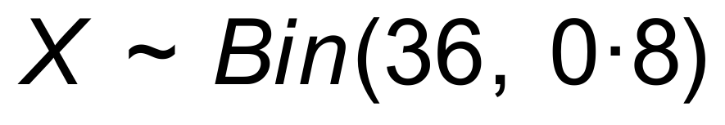
(a) 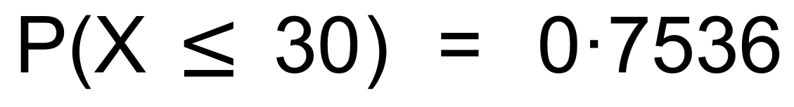
(b) (i) 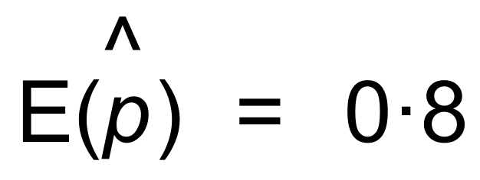
(ii) 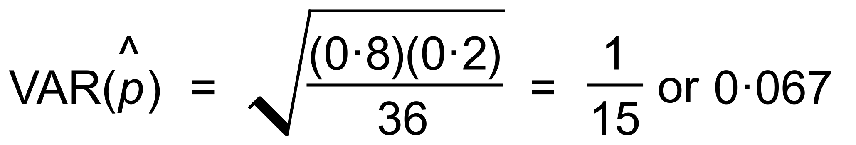
(c) (0.9)¹⁰ = 0.349 [7]
17. (a) Take proportions as follows:
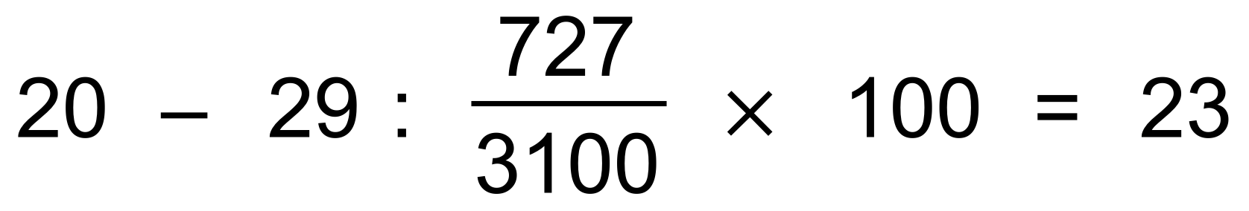
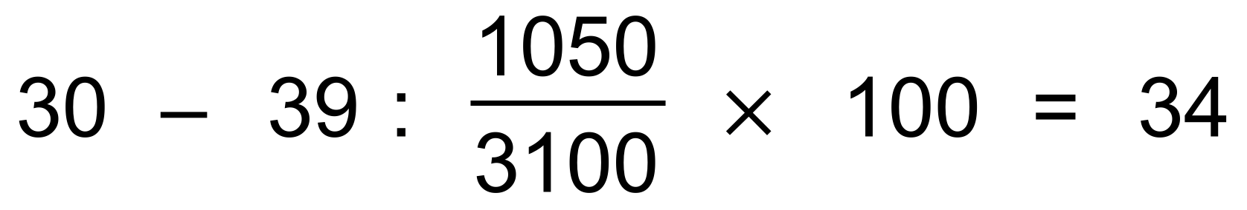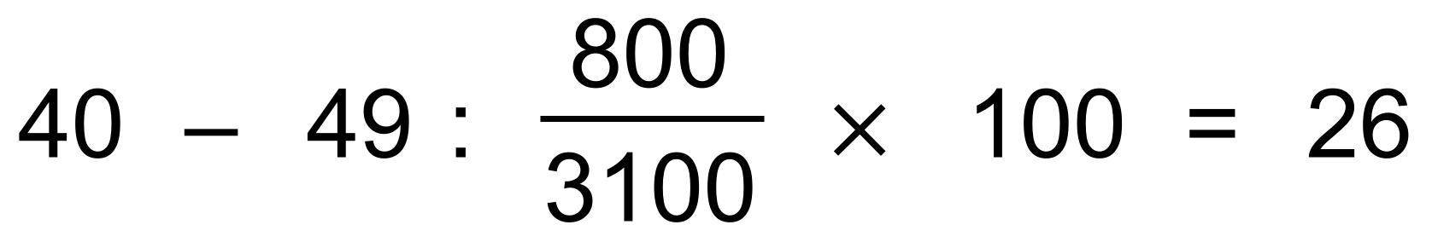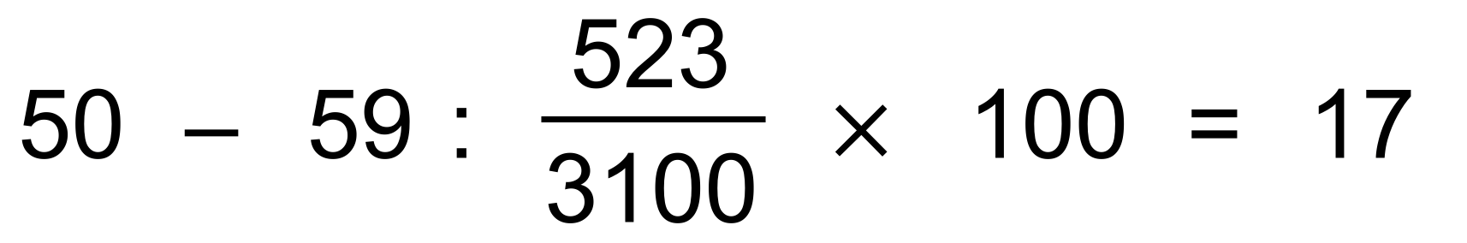
(b) (i) Normal distribution
(ii) 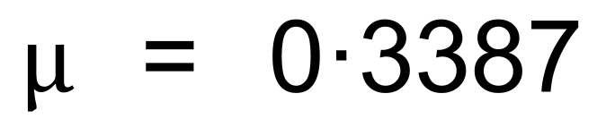
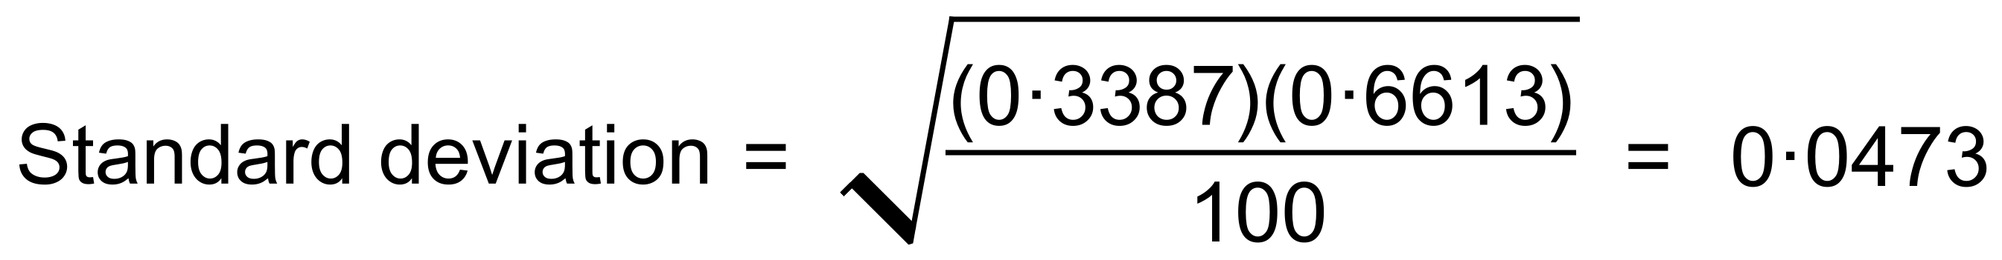
(c) 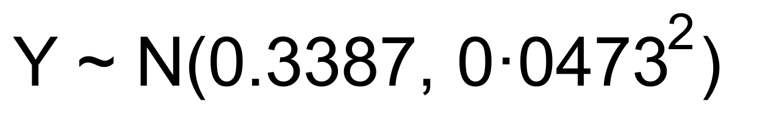
∴ [9]

18. (a) 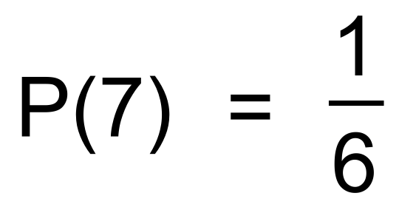
(b) 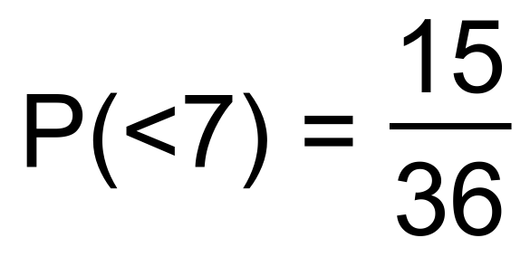
(c) 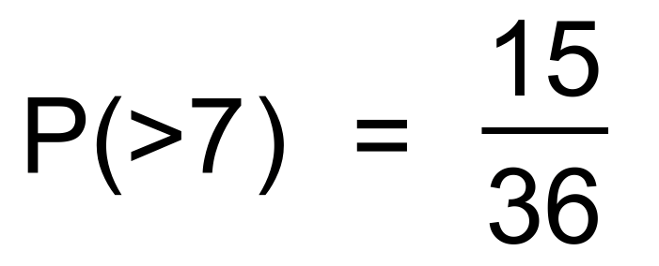
(d) $12
(e)
Game | 7s | Unders | Overs
P(X) | 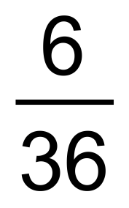 | 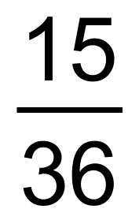 | 
Return | 20 | 1 | 1

∴ E(X) = 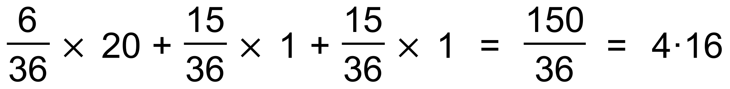
∴ Club makes $5 − $4.16 = 84 cents per roll [7]

19. (a)
= 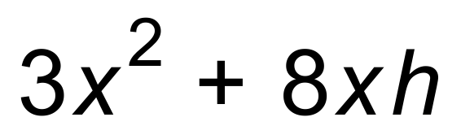
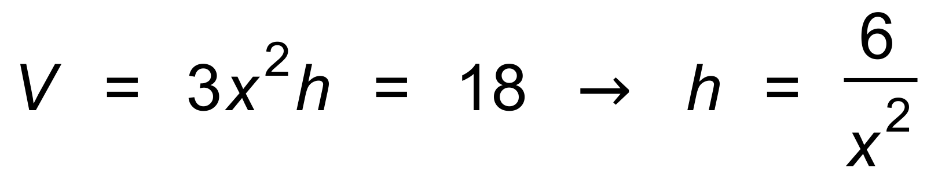
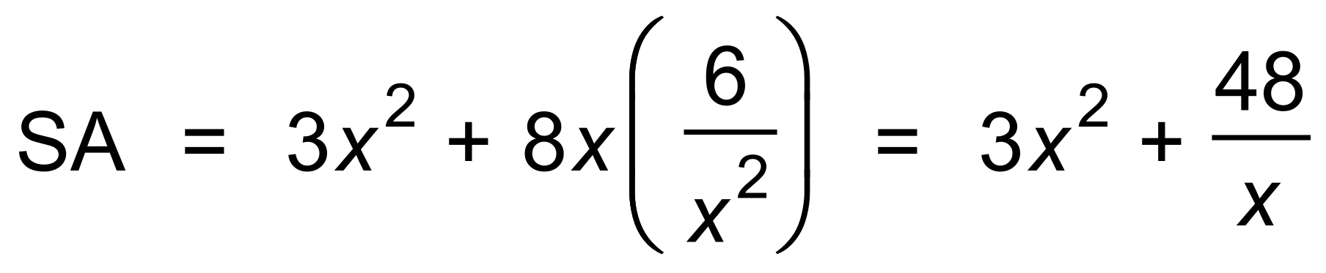
(b) 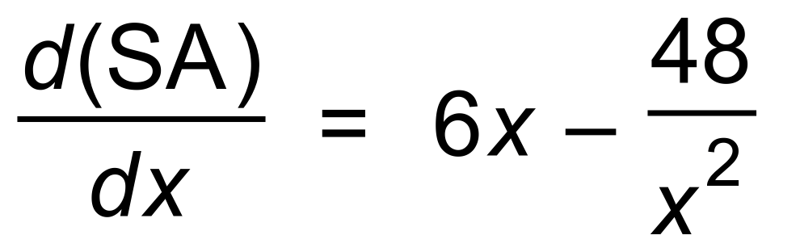
∴ Max occurs when 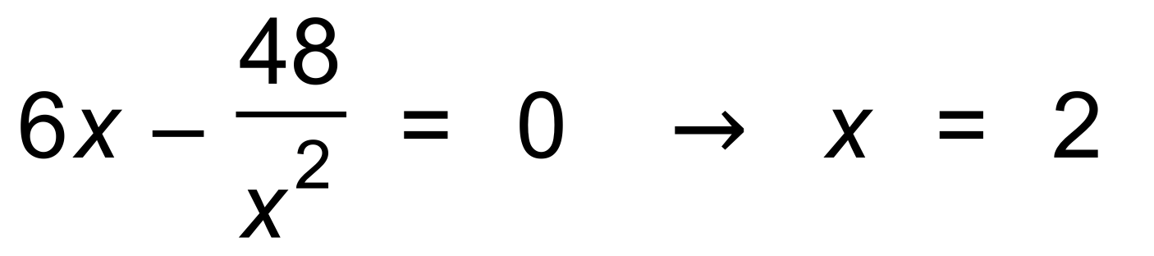
∴ h = 1.5 and SA = 36 m²
(c) 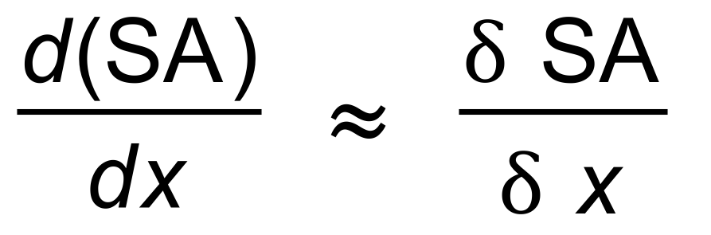
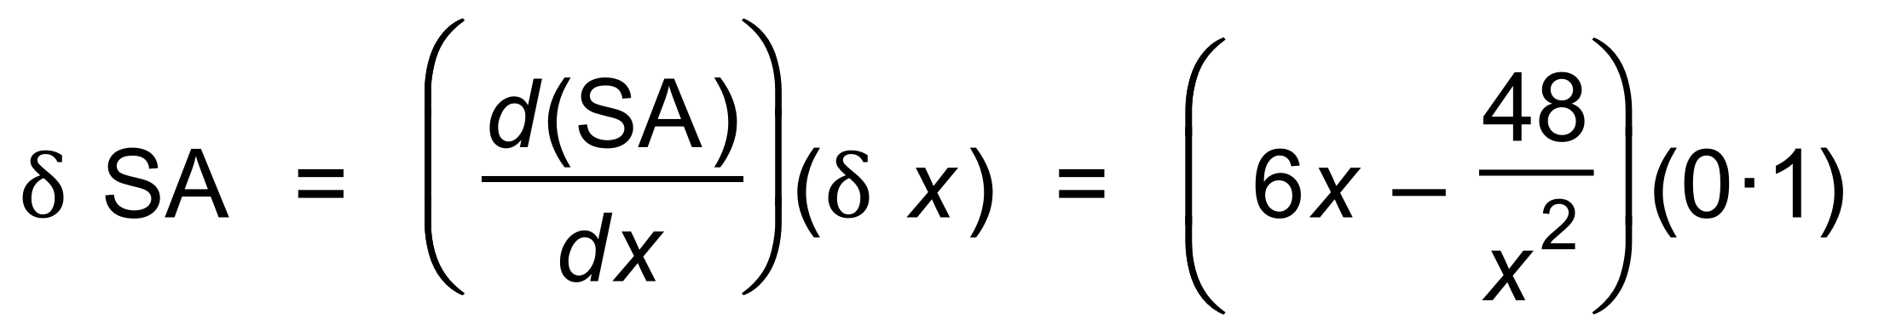
(d) 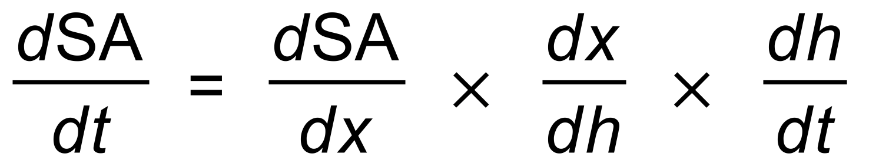
= 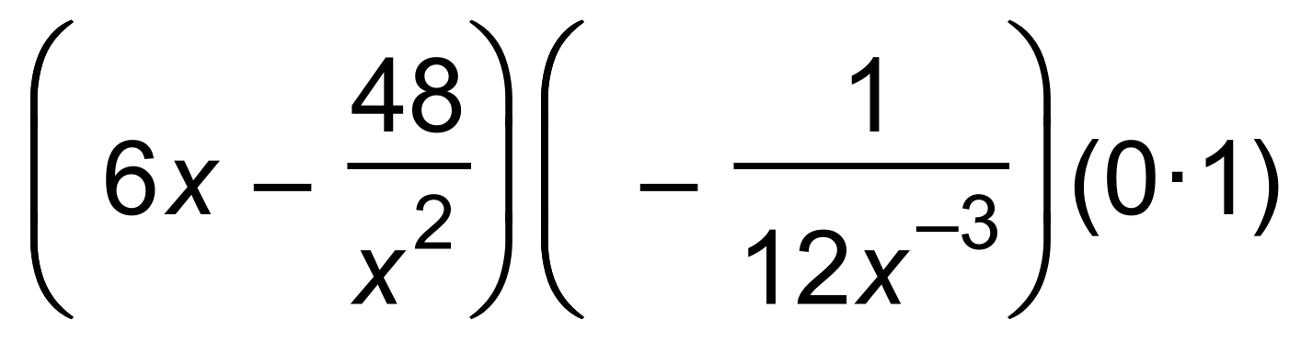
When x = 1, 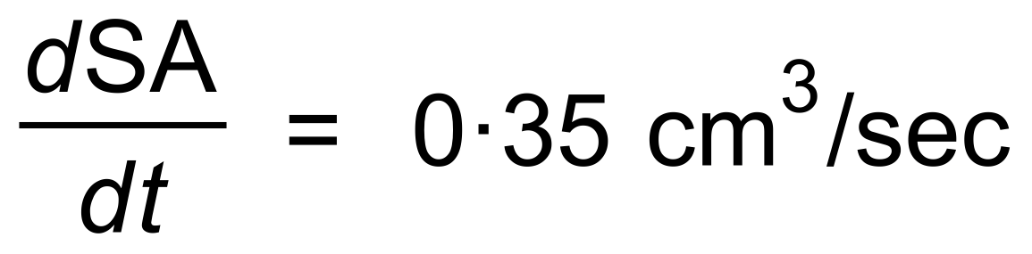 [11]

20. (a) 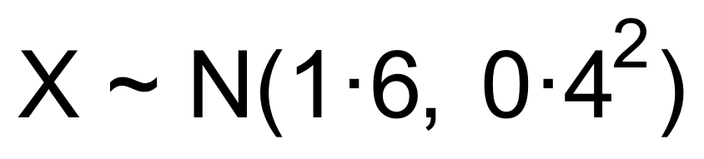
P(X > 2) = 0.1587
(b)
(c) (i) X ~ Bin(4, 0.1587)
∴ P(X = 1) = 0.378
(ii) 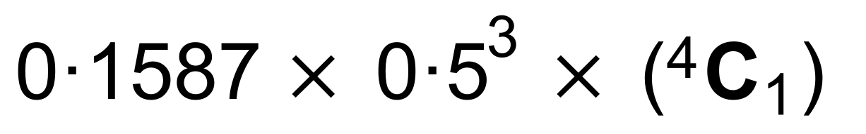
= 0.0794 [8]

